# **Login**

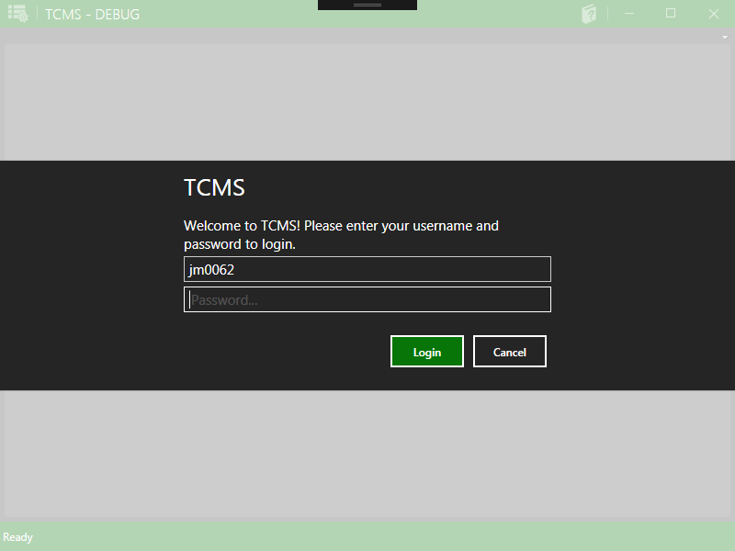

The first screen you will see when the application starts is the Login menu. This menu is self-explanatory. First, enter the username of the account you wish to log in as. Then, enter the password for that account. If the password is entered correctly, you will be taken to your Dashboard. If the password is entered incorrectly, or the username you entered does not exist in the database, you will be prompted with information of why your login failed, and you will be returned to the Login menu.

# **Dashboard**

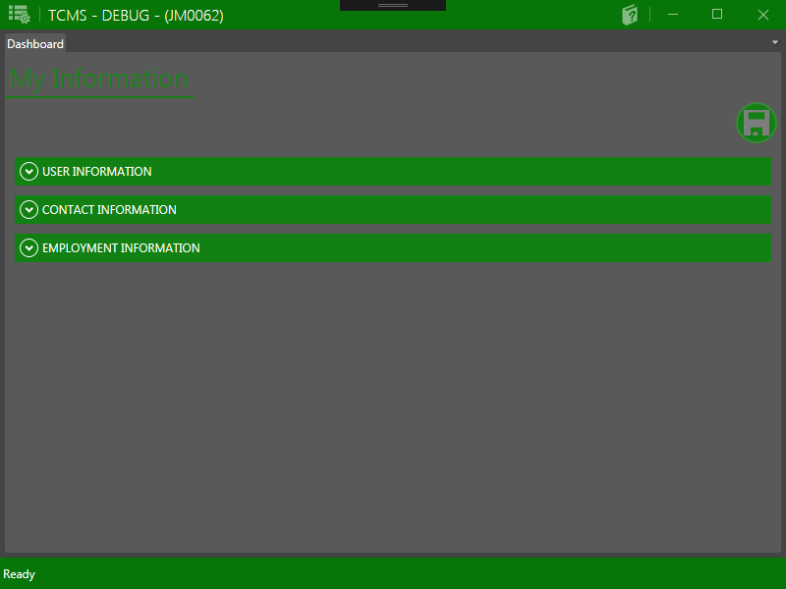The Dashboard is the first page you will see after successfully logging in. You can view your personal information on this menu, and also change your password. To view other menus, click the icon in the top-left corner of the window.

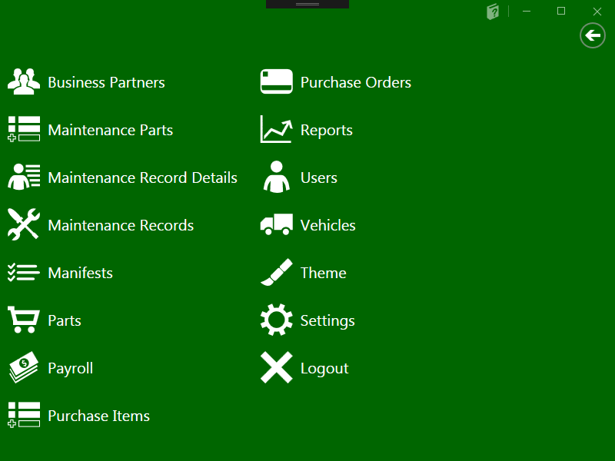This will bring up a list of menus available to your account. All accounts can personalize the color scheme of the application through the Theme menu. The menus available for viewing and editing will change depending on the access level of the account.

# **Driver Dashboard**

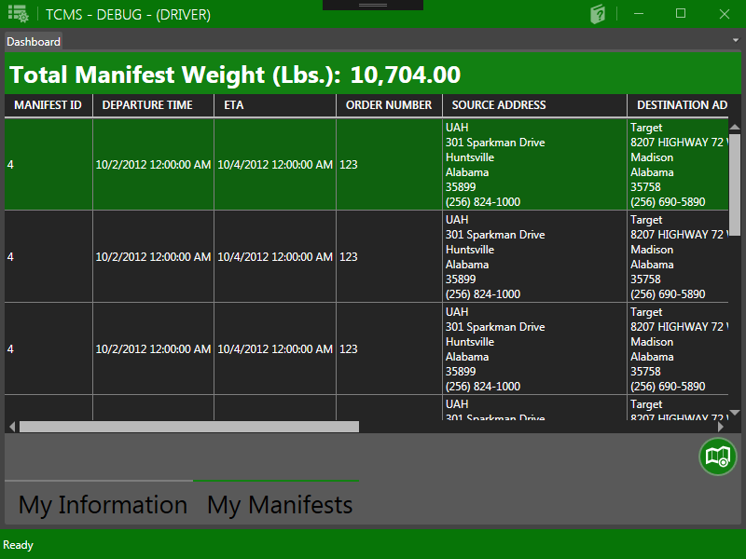Drivers have an extra feature on their Dashboard when they log in, called "My Manifests". This displays a list of manifests and purchase orders currently assigned to them. A map of the most efficient route is available (courtesy of Google Maps) by clicking the "Show Route" button in the bottom-right.

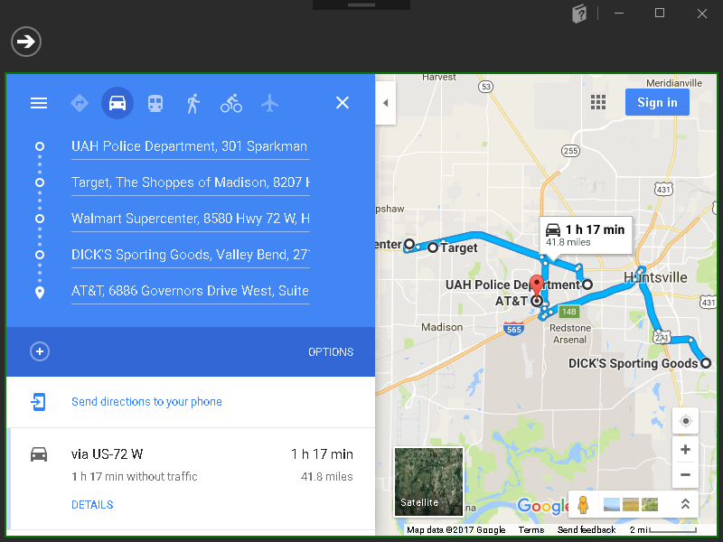

# **Users**

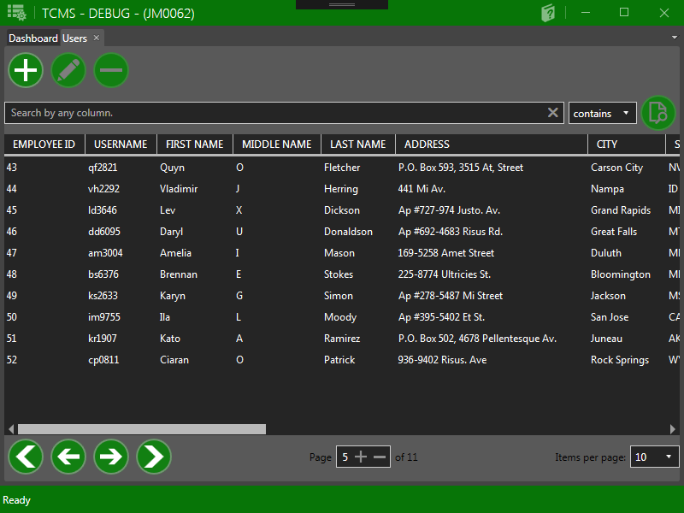The Users menu is only viewable by Full Access accounts. Here, users will be able to add, edit, or remove employee records and accounts by clicking the 3 buttons at the top of the menu, respectively (Note: you cannot view or change the passwords of existing accounts from the Users menu. If you wish to change the password, then you must log in as that user and change it via the Dashboard.) When a new user account is created, it will be given a default password, so it is highly recommended that the new user log in and change the password as soon as possible. You can search for specific accounts using the search bar, located directly below the add/edit/remove buttons, and can change the filtering method using the conditional drop-down menu next to it. The 4 buttons in the bottom-left allow you to navigate the list of employees by one page at a time, or by immediately moving to the first or last pages. You can also choose how many entries are displayed per page using the drop-down menu on the bottom-right of the menu

# **Vehicles**

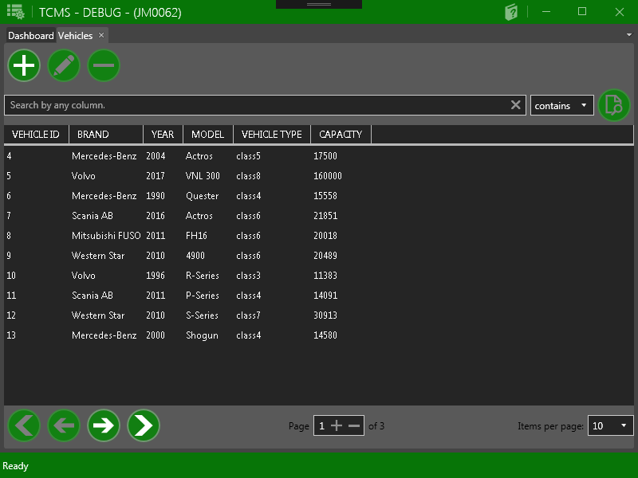The Vehicles menu displays all vehicles used by the company. Here, users will be able to add, edit, or remove vehicles by clicking the 3 buttons at the top of the menu, respectively. You can search for specific vehicles using the search bar, located directly below the add/edit/remove buttons, and can change the filtering method using the conditional drop-down menu next to it. The 4 buttons in the bottom-left allow you to navigate the list of vehicles by one page at a time, or by immediately moving to the first or last pages. You can also choose how many entries are displayed per page using the drop-down menu in the bottom-right.

# **Maintenance Records**

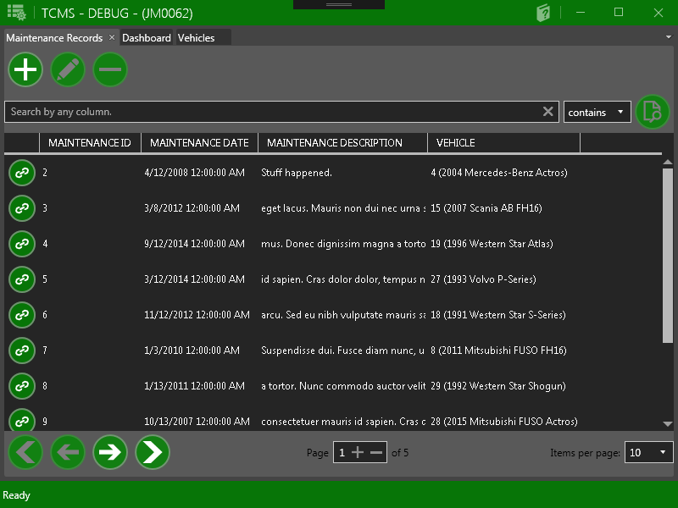The Maintenance Records menu displays the list of vehicle maintenance summaries, which include when maintenance was performed, and for which vehicle. Here, users will be able to add, edit, or remove records by clicking the 3 buttons at the top of the menu, respectively. You can search for specific records using the search bar, located directly below the add/edit/remove buttons, and can change the filtering method using the conditional drop-down menu next to it. The 4 buttons in the bottom-left allow you to navigate the list of records by one page at a time, or by immediately moving to the first or last pages. You can also choose how many entries are displayed per page using the drop-down menu in the bottom-right. Each maintenance record can have a set of maintenance record details associated with it. To view these details, click the link icon next to the record you wish to inspect. This will take you to the Maintenance Record Details menu.

# **Maintenance Record Details**

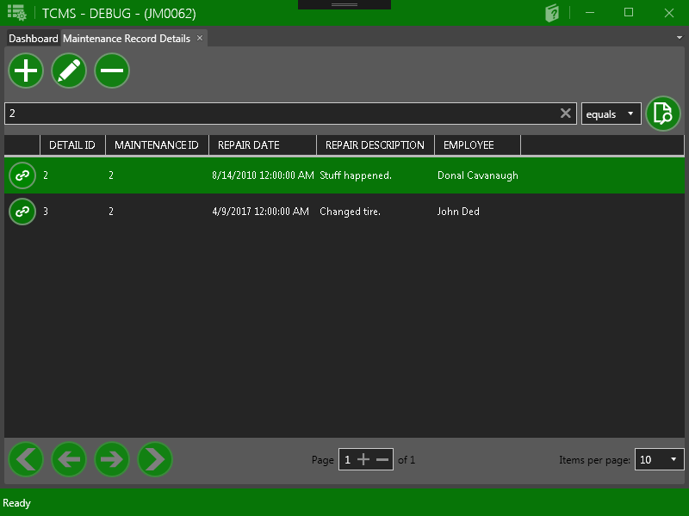The Maintenance Record Details menu displays the list of procedures and parts used for a vehicle's maintenance. Here, users will be able to add, edit, or remove record details to and from maintenance records by clicking the 3 buttons at the top of the menu, respectively. You can search for specific record details using the search bar, located directly below the add/edit/remove buttons, and can change the filtering method using the conditional drop-down menu next to it. The 4 buttons in the bottom-left allow you to navigate the list of record details by one page at a time, or by immediately moving to the first or last pages. You can also choose how many entries are displayed per page using the drop-down menu in the bottom-right. Each maintenance record detail has a part associated with it. To view the details of a part used in the maintenance, click the link icon next to the detail you wish to inspect. This will take you to the Maintenance Parts menu.

# **Maintenance Parts**

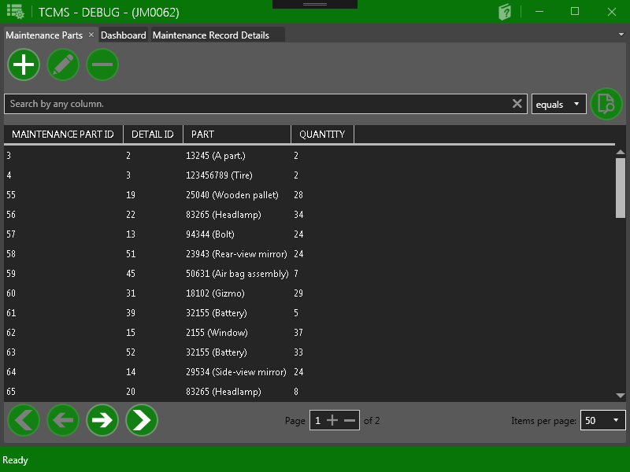The Maintenance Parts menu displays the list of parts used in the maintenance of company vehicles. Here, users will be able to add, edit, or remove record maintenance parts to and from record details by clicking the 3 buttons at the top of the menu, respectively. You can search for specific maintenance parts using the search bar, located directly below the add/edit/remove buttons, and can change the filtering method using the conditional drop-down menu next to it. The 4 buttons in the bottom-left allow you to navigate the list of maintenance parts by one page at a time, or by immediately moving to the first or last pages. You can also choose how many entries are displayed per page using the drop-down menu in the bottom-right.

# **Manifests**

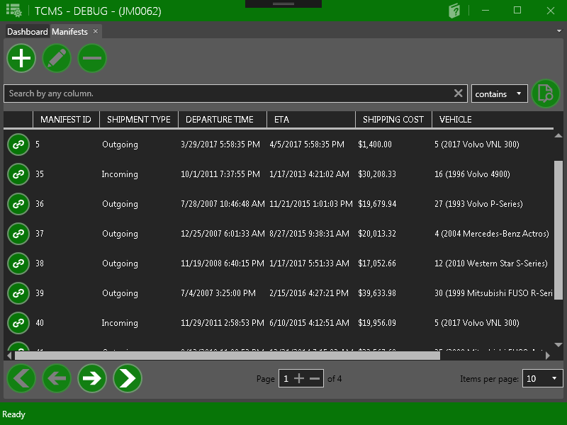The Manifests menu displays the list of shipping manifests, including their departure/arrival times, shipping costs, and the vehicle assigned to the shipment. Here, users will be able to add, edit, or remove manifests to and from vehicles by clicking the 3 buttons at the top of the menu, respectively. You can search for specific manifests using the search bar, located directly below the add/edit/remove buttons, and can change the filtering method using the conditional drop-down menu next to it. The 4 buttons in the bottom-left allow you to navigate the list of manifests by one page at a time, or by immediately moving to the first or last pages. You can also choose how many entries are displayed per page using the drop-down menu in the bottom-right.

# **Purchase Orders**

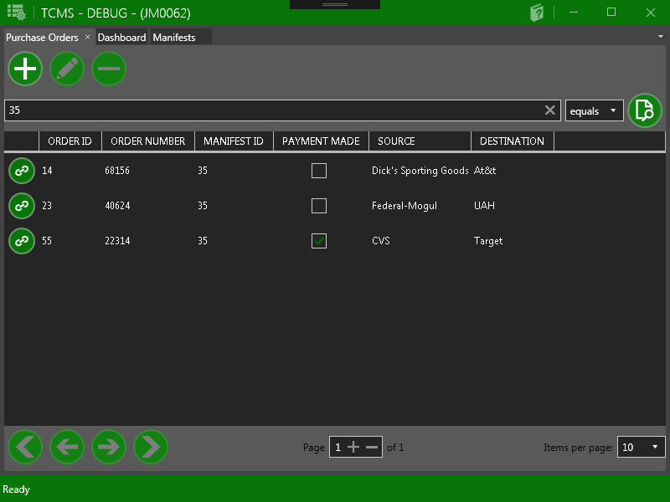The Purchase Orders menu displays the list of purchase orders, including the order's source and destination, and the shipping manifest it is associated with. Here, users will be able to add, edit, or remove purchase orders to and from manifests by clicking the 3 buttons at the top of the menu, respectively. You can search for specific purchase orders using the search bar, located directly below the add/edit/remove buttons, and can change the filtering method using the conditional drop-down menu next to it. The 4 buttons in the bottom-left allow you to navigate the list of purchase orders by one page at a time, or by immediately moving to the first or last pages. You can also choose how many entries are displayed per page using the drop-down menu in the bottom-right.

# **Purchase Items**

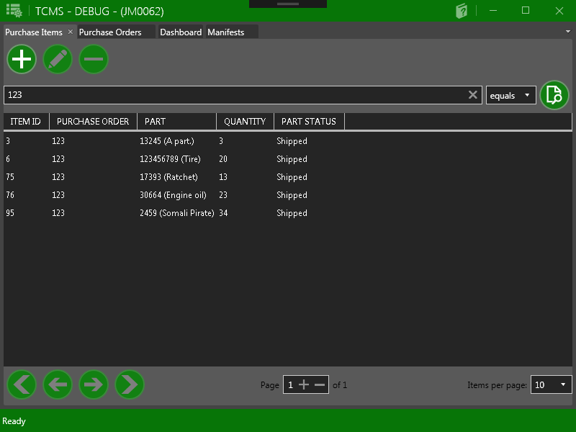The Purchase Items menu displays the list of items in purchase orders, including the quantity and the purchase order the item is associated with. Here, users will be able to add, edit, or remove items to and from orders by clicking the 3 buttons at the top of the menu, respectively. You can search for specific items using the search bar, located directly below the add/edit/remove buttons, and can change the filtering method using the conditional drop-down menu next to it. The 4 buttons in the bottom-left allow you to navigate the list of items by one page at a time, or by immediately moving to the first or last pages. You can also choose how many entries are displayed per page using the drop-down menu in the bottom-right.

# **Parts**

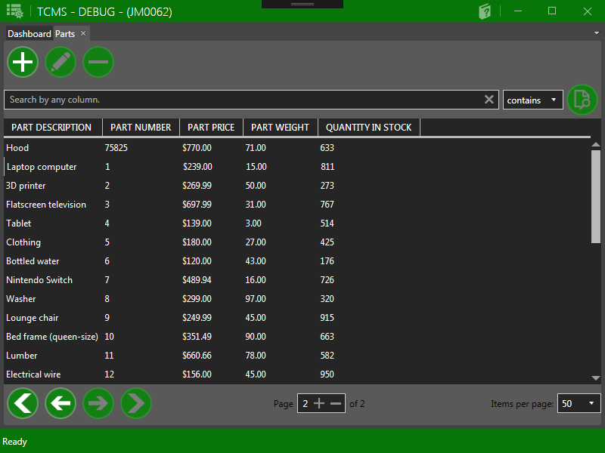The Parts menu displays a list of all items in inventory, including their price, unit weight, and quantity in stock. Here, users will be able to add, edit, or remove parts by clicking the 3 buttons at the top of the menu, respectively. You can search for specific parts using the search bar, located directly below the add/edit/remove buttons, and can change the filtering method using the conditional drop-down menu next to it. The 4 buttons in the bottom-left allow you to navigate the list of parts by one page at a time, or by immediately moving to the first or last pages. You can also choose how many entries are displayed per page using the drop-down menu in the bottom-right.

# **Payroll**

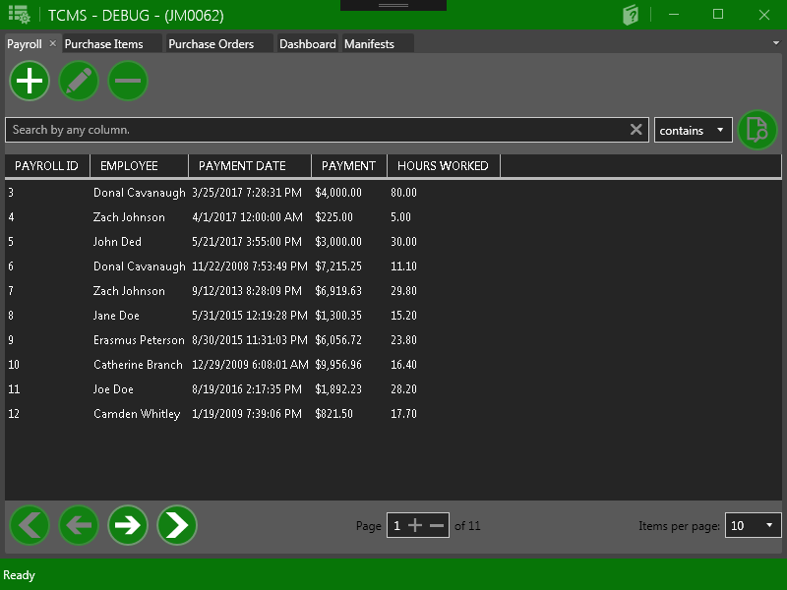The Payroll menu displays a list of payments made to employees, including the date the payment was made and how many hours that employee has worked. Here, users will be able to add, edit, or remove payrolls by clicking the 3 buttons at the top of the menu, respectively. You can search for specific payrolls using the search bar, located directly below the add/edit/remove buttons, and can change the filtering method using the conditional drop-down menu next to it. The 4 buttons in the bottom-left allow you to navigate the list of payrolls by one page at a time, or by immediately moving to the first or last pages. You can also choose how many entries are displayed per page using the drop-down menu in the bottom-right.

# **Reports**

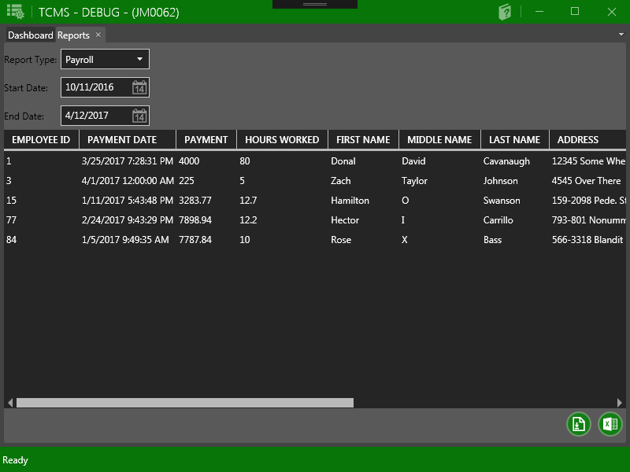The Reports menu allows users to generate summary reports for employee payrolls, maintenance records, and incoming and outgoing shipments. First, select the type of report you wish to generate. If you wish to generate a Maintenance Cost or Payroll report, then you must also specify the date range the report should cover. If you wish to generate a Vehicle Maintenance report, you must select the vehicle whose maintenance records you wish to view. Finally, click the "Run Report" button in the bottom-right (left button) to retrieve the data specified. You can also export the generated report as a Microsoft Excel table (.xls) by clicking the "Export Report to Excel" button, also in the bottom-right (right button).